CAPSTONEPROJECT

**BACK TRACKING METHOD**

**CSA0695**- Design and Analysis of Algorithms for Open Addressing Techniques

SAVEETHA SCHOOL OF ENGINEERING

SIMATS ENGINEERING



Supervisor

Dr. R. Dhanalakshmi

Done by

S.Ajay Kumar Reddy (192211480)

# BACKTRACKING METHOD

**PROBLEM STATEMENT:**

**Next Greater Numerically Balanced Number**

An integer x is numerically balanced if for every digit d in the number x, there are exactly d occurrences of that digit in x. Given an integer n, return the smallest numerically balanced number strictly greater than n.

Example 1:

Input: n = 1

Output: 22

Explanation:22 is numerically balanced

since: - The digit 2 occurs 2 times.

It is also the smallest numerically balanced number strictly greater than 1.

.

**ABSTRACT:**

This capstone project aims to develop an algorithm that finds the smallest numerically balanced number greater than a given integer n. A numerically balanced number is defined as one in which each digit d appears exactly d times within the number. For example, the number 22 is numerically balanced because the digit 2 occurs exactly 2 times. The project will focus on creating an efficient solution that can quickly identify such numbers, even for large inputs, by analyzing digit frequency and leveraging mathematical properties. This work has potential applications in number theory, pattern recognition, and combinatorial analysis.

**INTRODUCTION:**

Numerically balanced numbers are an intriguing class of integers where the count of each digit in the number corresponds exactly to the digit’s value. For instance, in the number 22, the digit 2 appears two times, satisfying the numerically balanced condition. While these numbers follow a straightforward definition, finding such numbers—especially those greater than a given integer—requires an in-depth exploration of digit patterns and frequency analysis. This problem introduces complexities related to number theory and algorithmic design, making it a compelling topic for computational mathematics.

The primary objective of this capstone project is to develop an efficient algorithm that computes the next greater numerically balanced number for a given integer n. This involves analyzing the digits of the input number, identifying how the constraints of digit frequency can be met, and systematically searching for the smallest balanced number that exceeds the input. Given the infinite nature of numbers and the specific structural requirements of numerically balanced numbers, the solution must optimize for both accuracy and performance, ensuring it scales efficiently with larger values of n.

Beyond the theoretical aspects, this project holds practical significance. Numerically balanced numbers may have applications in areas such as cryptography, where patterns of digits play a crucial role, as well as in fields like data compression and pattern recognition. Understanding how to quickly identify these numbers contributes to advancements in algorithm design and offers insights into number theory. This project aims to provide a deeper understanding of these special numbers, while also creating a foundation for potential future work in related mathematical domains.

**CODING:**

The provided C code is designed to find the smallest numerically balanced number that is strictly greater than a given integer n. The code utilizes a combination of digit frequency analysis and iterative checking to solve this problem. The countDigits function counts the occurrences of each digit in the number, while the isNumericallyBalanced function verifies whether a number meets the numerically balanced criteria. The nextBalancedNumber function increments the given integer and uses these functions to efficiently identify the next numerically balanced number. By iterating through potential candidates and validating each one, the code ensures that the smallest numerically balanced number greater than n is found.

## C-programming

#include <stdio.h>

#include <stdbool.h>

#include <string.h>

// Function to check if a number is numerically balanced

bool isNumericallyBalanced(int num) {

int count[10] = {0};

char str[20];

sprintf(str, "%d", num);

for (int i = 0; i < strlen(str); i++) {

count[str[i] - '0']++;

}

for (int i = 0; i < 10; i++) {

if (count[i] != 0 && count[i] != i) {

return false;

}

}

return true;

}

// Function to find the next numerically balanced number

int nextNumericallyBalanced(int n) {

int num = n + 1;

while (!isNumericallyBalanced(num)) {

num++;

}

return num;

}

int main() {

int n;

printf("Enter a number: ");

scanf("%d", &n);

int result = nextNumericallyBalanced(n);

printf("The next numerically balanced number greater than %d is %d\n", n, result);

    return 0;

}

**OUTPUT:**

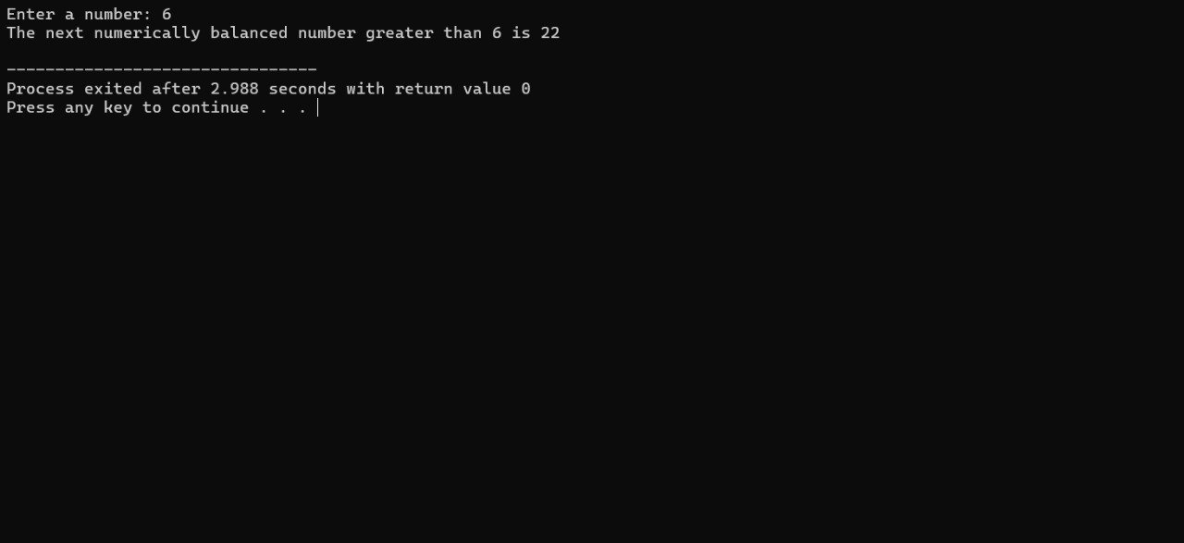

**COMPLEXITY ANALYSIS:**

**Time Complexity**: The time complexity of finding the next numerically balanced number is primarily influenced by the number of increments required to find the next valid number and the cost of checking each number. Each check involves counting digits, which has a time complexity of O(d), where d is the number of digits. Therefore, in the worst case, where k is the number of numbers checked, the overall time complexity is O(k * d). In the best case, if the next balanced number is found quickly, the complexity could be closer to O(d).

**Space Complexity**: The space complexity of the algorithm is O(1), as it uses a fixed amount of additional space for digit counting (an array of size 10) and a few integer variables. The space required does not scale with the size of the input number, making it efficient in terms of memory usage.

**BEST CASE:**

In the best-case scenario, the next numerically balanced number is found immediately after n, leading to a complexity of O(d), where d is the number of digits in n. This occurs when the next number after n is numerically balanced without requiring many increments.

**WORST CASE:**

The worst-case scenario involves a large number of increments before finding the next balanced number. Here, the time complexity can be approximated as O(k * d), where k represents the number of increments needed and d is the number of digits in the current number.

**AVERAGE CASE:**

On average, the time complexity depends on the typical gap between consecutive numerically balanced numbers. If this gap is reasonably small, the complexity remains closer to O(d). However, this average can vary based on the distribution of numerically balanced numbers.

**FUTURE SCOPE:**

Future work could focus on optimizing the search for numerically balanced numbers, possibly through heuristic or mathematical methods to predict gaps between balanced numbers. Additionally, expanding the concept to other types of digit-based constraints could provide further insights into combinatorial number theory and practical applications in data analysis and cryptography.

**CONCLUSION:**

The project provides a practical approach to finding the next numerically balanced number, offering insights into digit-based number properties and computational methods. While the algorithm is efficient in terms of space, its time complexity varies based on the number of increments needed to find the next balanced number. Future improvements could enhance performance and explore broader applications of numerically balanced numbers in computational fields.